**DEPARTMENT OF INFORMATION**

**AND COMMUNICATION TECHNOLOGY**

|  |
| --- |
| **DFP30243:**  **OBJECT ORIENTED PROGRAMMING** |

|  |  |
| --- | --- |
| **NAME:** | MUHAMMAD AFIQ MUHAIMIN BIN MOHD ZAINI |
| **CLASS :** | DDT3A |
| **REGISTRATION NO :** | 32DDT20F2029 |
| **LECTURER :** | PN. HAZLEENA BINTI OSMAN  PN. RODZIAH BT IBRAHIM |
| **NAME OF TASK:** | LAB ACTIVITY 3 |

LAB ACTIVITY 3:

CLASSES AND OBJECTS

**Learning Outcomes:**

By the end of this laboratory session, you should be able to:

1. Implement type casting to change the data type
2. Implement input stream (System.in) and output stream (System.out) in Java programming.
3. Write Java program using variables, operators and Input/Output stream

**Hardware/Software:** Computer with JDK latest version.

**Activity 3A**

Activity Outcome: Implements typecasting in Java programs.

The following program shows the implicit and explicit type casting.

Procedures:

**Step 1:** Open Notepad and type the following code:

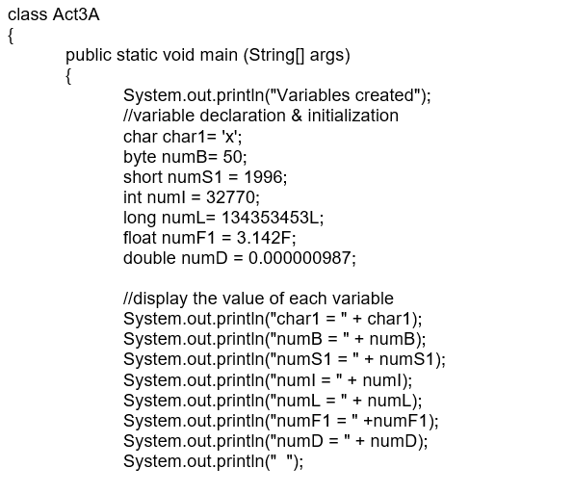

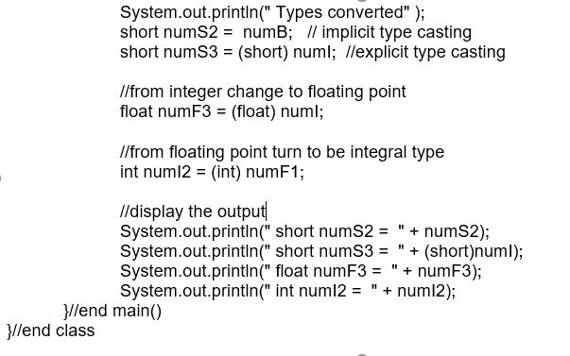

**Step 2:**  Save, compile and run the program. Save the program as Act3A.java. Observe the output.

**Output:**

**Activity 3B**

Activity Outcome: Implements input stream (System.in) and output stream (System.out) in Java programs.

The following program show how to accepts input data using input stream, convert string value to integer and display data using output stream**.**

Procedures:

**Step 1:** Open Notepad and type the following code:

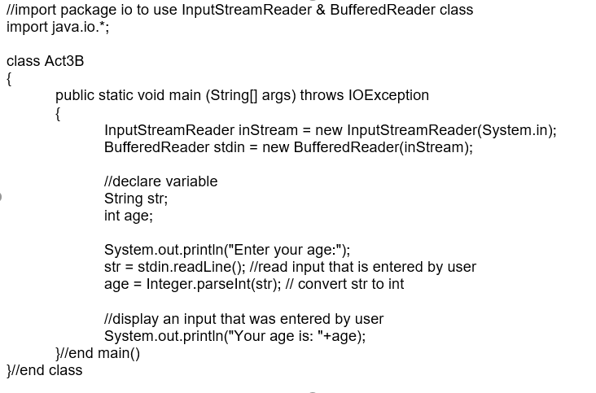

**Step 2:**  Save, compile and run the program. Save the program as Act3B.java. Observe the output.

**Output:**



**Activity 3C**

Activity Outcome: Implements input stream (System.in) and output stream (System.out) in Java programs.

The following program below show how to accept input from the command line.

Procedures:

**Step 1:** Open Notepad and type the following code:

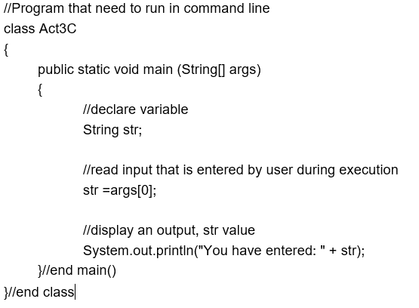

**Step 2:**  Save, compile and run the program. Save the program as Act3C.java. Observe the output.

**Output:**

**Activity 3D**

Activity Outcome: Implements input stream (System.in) and output stream (System.out) in Java programs.

The following program below show how to accept input and use mathematical operator to calculate the numbers that is entered by user.

Procedures:

**Step 1:** Open Notepad and type the following code:

//import package io to use InputStreamReader & BuffredReader class

import java.io.*;

class Act3D

{

public static void main (String[] args) throws IOException

{

BufferedReader inData = new BufferedReader(new InputStreamReader(System.in));

//declare variable

String str;

String num1, num2, num3;

int number1, number2, number3;

System.out.println("Enter your name : ");

str = stdin.readLine();//read input that is entered by user

System.out.println("Enter first number : ");

num1 = stdin.readLine();//read input that is entered by user

//convert @parsing String(num1) to integer data type

number1=Integer.parseInt(num1);

System.out.println("Enter second number : ");

num2 = stdin.readLine();//read input that is entered by user

//convert @parsing String(num1) to integer data type

number2=Integer.parseInt(num2);

System.out.println("Enter third number : ");

num3 = stdin.readLine();//read input that is entered by user

//convert @parsing String(num1) to integer data type

number3=Integer.parseInt(num3);

//calculate number1, number2 & number3

int total = number1+number2*(number3/number1);

//display output

System.out.println("Details:");

System.out.println("Name entered: " + str);

System.out.println("Number entered: " + number1 +

"," + number2 + "," + number3);

System.out.println(“The total is: “+ total);

}//end main()

}//end class

**Step 2:**  Save, compile and run the program. Save the program as Act3D.java. Observe the output.

**Output:**



**Activity 3E**

Activity Outcome: Implements input stream (System.in) and output stream (System.out) in Java programs.

The following program show how to accept input and use mathematical operator to calculate the numbers entered by user. This program is used Scanner class from util package to accept input from user.

Procedures:

**Step 1:** Open Notepad and type the following code:

**Step 2:**  Save, compile and run the program. Save the program as Act3E.java. Observe the output.

//import util package to use Scanner class

import java.util.*;

class Act3E {

public static void main(String[] args) {

System.out.println("Enter any THREE numbers : ");

//create object of Scanner to invoke method from Scanner class.

Scanner sc = new Scanner(System.in);

/*A Scanner breaks its input into tokens using a delimiter pattern, which by default matches whitespace. The resulting tokens may then be converted into values of different types using the various next methods.*/

int num1 = sc.nextInt();

int num2 = sc.nextInt();

int num3 = sc.nextInt();

//calculate num1, num2, num3

int sum = num1*num2-num3;

//display an output, sum

System.out.println("The sum is: "+sum);

}//end main()

}//end class

**Output:**

**State the differences between InputStreamReader class and Scanner class:**

|  |  |
| --- | --- |
| **Scanner Class** | **InputStreamReader** |
| Scanner is slower in terms of performance | InputStreamReader is faster in terms of performance |
| Scanner can’t read whole document character by character | InputStreamReader can read whole document character by character |
| Scanner is not easy to control its function | You have more control if you use InputStreamReader |